1. **FLIGHT_HAULT , CONNECTING ROUTES.**

Connecting routes edgelist graph:

conn_routesNW <- graph.edgelist(as.matrix(connecting_routes[, c(3, 5)]), directed = TRUE)

plot(conn_routesNW)



conn_routesNW <- graph.edgelist(as.matrix(connecting_routes[1:200, c(3, 5)]), directed = TRUE)

plot(conn_routesNW)

For first 200 entries:

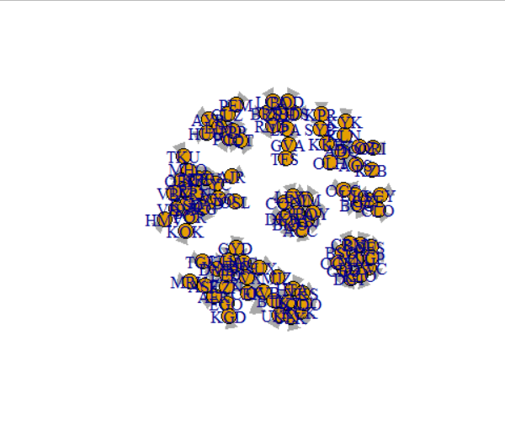

**INDEGREE:**

ARN has the highest indegree of all , Others are LED ,MNL in order

# 13 max indegree of an airport

#ARN has 13 indgeree which is max

which(flight$IATA_FAA == "ARN") # ARN is located at index 727 from fligth dataset.

ARNdata <- flight[727, ] # view its full detail in a dataframe

**CLOSENESS:**

closeness_in

== 0.01345969

# SVX with closeness of 0.13

which(flight$IATA_FAA == "SVX")

flight[2896, ]

#SVX has the most closeness with other airports .at index location 2896

ID Name City Country IATA_FAA ICAO Latitude Longitude Altitude Time DST

2896 2975 Koltsovo Yekaterinburg Russia SVX USSS 56.74311 60.80273 764 6 N

Tz database time

2896 Asia/Yekaterinburg

**OUTDEGREE:** --- ARN (Stockholm ,Sweden) is the busiest airport with most indegree and outdegree .saying that it has a lot of flight scheduled.

# 13 outdegere

# ARN has highest outdegree and indegree

which(flight$IATA_FAA == "ARN")

flight[727, ]

ID Name City Country IATA_FAA ICAO Latitude Longitude Altitude Time DST Tz database time

727 737 Arlanda Stockholm Sweden ARN ESSA 59.65194 17.91861 137 1 E Europe/Stockholm

**CENTRALITIES:**

inDegree outDegree closenessIn betweenness

AER 1 1 0.01340629 0.000000000

KZN 7 7 0.01345045 0.028769549

ASF 2 2 0.01340996 0.004944246

MRV 1 1 0.01336607 0.000000000

CEK 3 3 0.01344307 0.010993057

OVB 6 5 0.01345230 0.030044183

**CORRELATIONS WITH OTHER CENTRALITIES WILL DEFINE .WHICH RELY ON OTHER.**

> cor(centralities)

inDegree outDegree closenessIn betweenness

inDegree 1.0000000 0.9528681 0.2034420 0.7889648

outDegree 0.9528681 1.0000000 0.1794776 0.7544998

closenessIn 0.2034420 0.1794776 1.0000000 0.3596856

betweenness 0.7889648 0.7544998 0.3596856 1.000000

Highest Correlation between InDegree and OutDegree with 0.95.

plot(centralities[, "inDegree"], centralities[, "outDegree"]) 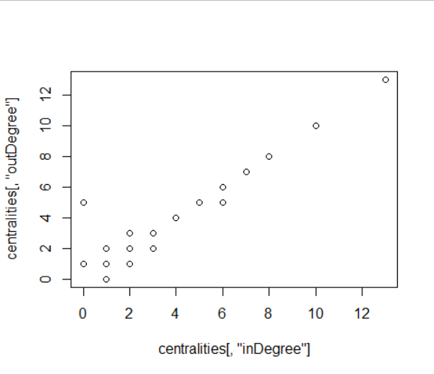

**EIGENVECTOR CENTRALITIES:** ARN has the highest eigen centrality since it also has most influence of indegree and outdegree.

?eigen_centrality

max(eigenv$vector) # ARN with th maximum eigenvector centrality of 2.05

2.053913e-15

which(flight$IATA_FAA == "ARN")

flight[3584, ]

**PAGERANK : ARN is the highest pagerank because of its influence.**

PageRank is an algorithm that measures the **transitive** influence or connectivity of nodes.

It can be computed by either iteratively distributing one node’s rank (originally based on degree) over its neighbours or by randomly traversing the graph and counting the frequency of hitting each node during these walks.

1. DATASETS OF SOCIAL MEDIA ADJACENY MATRIX:

**2.1)FACEBOOK**:

g1 <- graph.adjacency(as.matrix(fb), mode="undirected")

plot(g1)

Degree of centrality from the given FB binary data is 2 2 2 2 2 2 2 2 2

degree.cent <- centr_degree(g1, mode = "all")

degree.cent$res # [1] 2 2 2 2 2 2 2 2 2

Closeness of centrality of FB: 0.4

closeness.cent <- closeness(g1, mode="all")

closeness.cent

plot(g1, layout=layout.sphere, main="sphere")

plot(g1, layout=layout.circle, main="circle")

plot(g1, layout=layout.random, main="random")

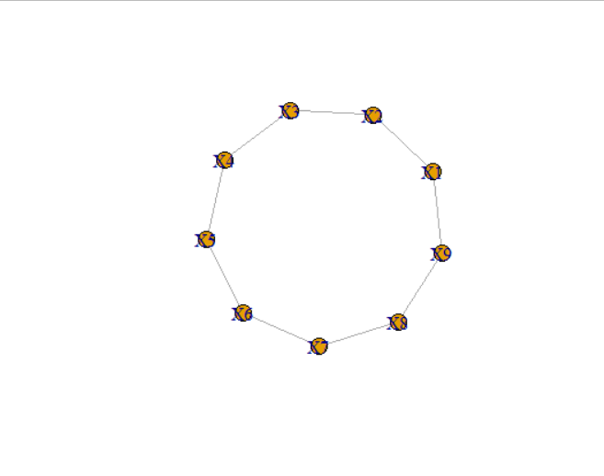

**2.2)Linkedin:**

g2 <- graph.adjacency(as.matrix(ln), mode="undirected")

plot(g2, layout=layout.sphere, main="sphere")

plot(g2, layout=layout.circle, main="circle")

plot(g2, layout=layout.random, main="random")

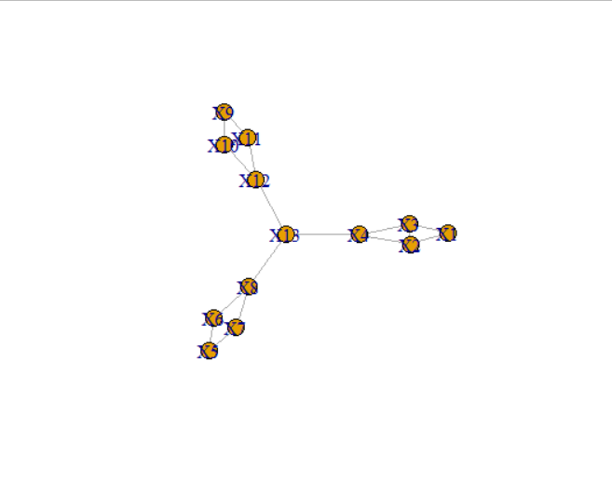

UNDIRECTED STAR GRAPH

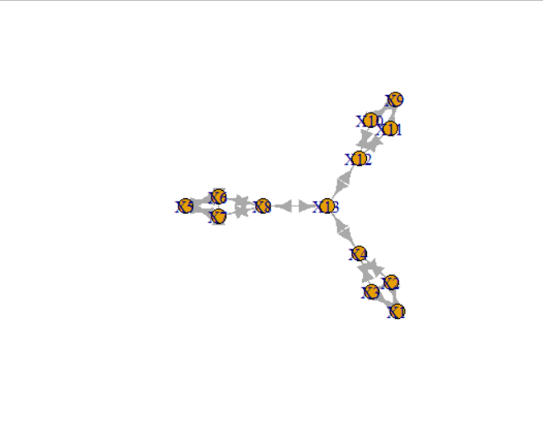

DIRECTED GRAPH

From the above star graph it seems like X13 is most influence on other nodes. It is important to serve this noe as it connects other node.It has a high

DEGREE OF CENTRALITY OF THE GIVEN LINKED IN DIRECTED GRAPH IS:

degree.cent <- centr_degree(g2, mode = "in")

degree.cent$res # 2 3 3 3 2 3 3 3 2 3 3 3 3

CLOSENESS OF EACH VERTEX:

X1 X2 X3 X4 X5 X6 X7 X8

0.02127660 0.02702703 0.02702703 0.03448276 0.02127660 0.02702703 0.02702703 0.03448276

X9 X10 X11 X12 X13

0.02127660 0.02702703 0.02702703 0.03448276 0.04166667

MAX IS >> max(closeness.cent)

[1] 0.04166667 which is X13

**2.3)INSTAGRAM:**

g3 <- graph.adjacency(as.matrix(insta), mode="undirected")

plot(g3)

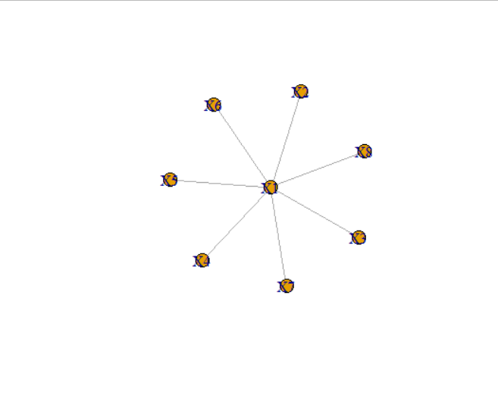

X1 IS CENTRE AND ALL NODES ARE CONNECTED TO EACH OTHER VIA X1, Hence thid star topology.

DEGREE OF CENTRALITY OF EACH NODES IS: 7 1 1 1 1 1 1 1

degree.cent <- centr_degree(g1, mode = "all")

degree.cent$res 7 1 1 1 1 1 1 1

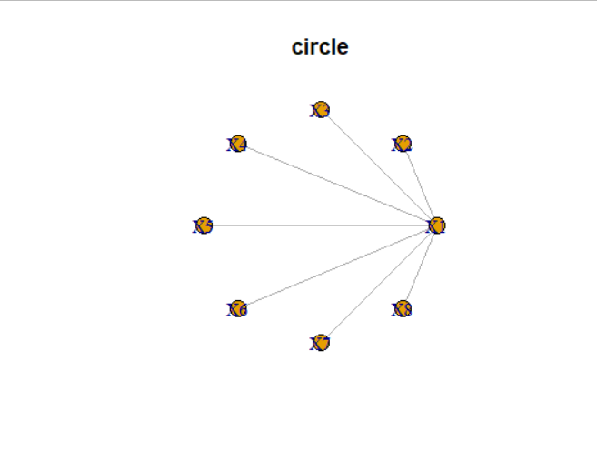

plot(g3, layout=layout.sphere, main="sphere")

plot(g3, layout=layout.circle, main="circle")

plot(g3, layout=layout.random, main="random")